INFO 7390

**Assignment 3 Report**

Processor: Sri Krishnamurthy

Group 1

Chang Yu, Songzhe Zhang, You Li

**Project Statement**

In this case we tried to analyze the consumption of every single property, and then predicted the consumption for the next year. We combined the weather data and holiday data with the original dataset. And create a web page for the application.

The link of the application is [liyouneu.com](http://liyouneu.com/), which is running on AWS Elastic Beanstalk. The main page is for the micro analysis for every single building, the macro analysis is not finished. The visualization tag is for the visualization we did in Tableau.

# **1.Pre-process**

1.1 Original Data

Original Data is 73 csv files each represent the electricity consumption of one building. The category and building name information are included in the file names. In the csv files, Account, Date, Channel, Unit and time from 0:05 to 24:00 are columns and electricity consumption information are included in each row.





1.2 Target Dataset Format

For convenient using the dataset to build prediction model, we need to transform the dataset to the format which Account, Date, Time, kWh, PowerFactor and kVARh are columns and the consumption of electricity are in each row.



1.3 Transform Dataset

1.3.1 Transpose Dataset

For mutil-apply the transformation to all the files, we decide to use R as tool to complete the transformation. The first step to transform dataset is to transpose the Units and time columns and combine them whit Account and Date. Then we will add the Category and building name which extracted from the file name to the dataset. Last but not lest, we derive the day, month and year from date column and combine them with other data. Using R-1 code, we accomplished this transformation and get the result. (R code will be attached to the end of the report)



1.3.2 Merge Consumption by Date

Because the time scale is too small to use, we decided to sum the electricity consumption by date. Using code R-2, we get the daily consumption of electricity.



.

1.4 Combining Columns

Firstly, we import the data from: <https://www.wunderground.com/>

In the type of csv format;

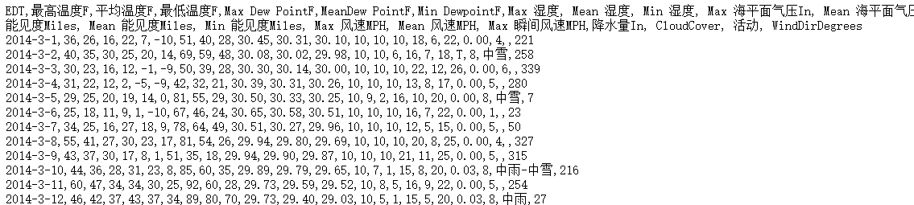

Then we transform the date data in to the same type of that in Boston Energy and combine them together in R-sql

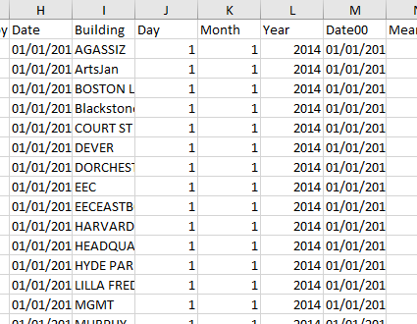



After we collect weather info from web source, we using sqldf() function combine different functions together.

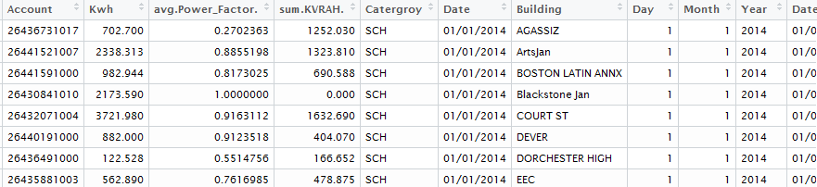

1.5 Clean NA and Zero Value Data

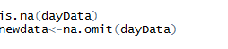

1.6 The Final Dataset

After pre-process of the dataset, we get the final dataset which will be used in training and evaluating model.



# **2.Visualization Analytic**

2.1 Marco Analysis

Total Energy Consumption – Month/Day

In the graph, it’s very clear that the macro energy consumption changes month by month. This will help us understand the relationship between different month and their energy consumptions.

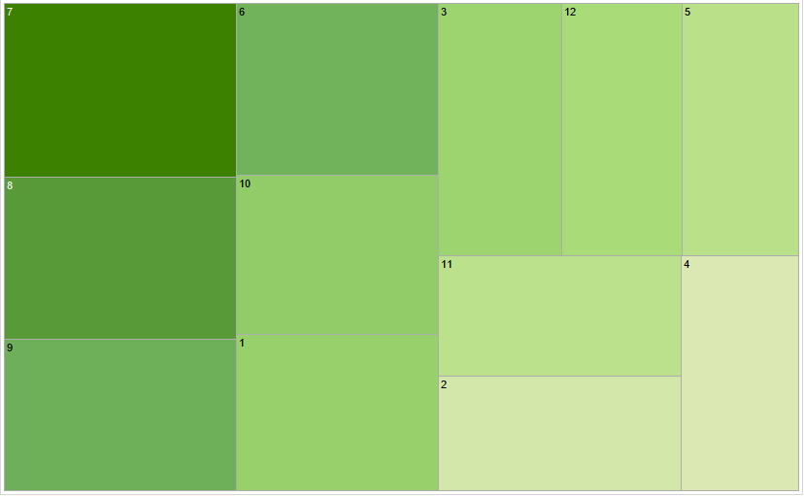

The graph below displays the range of daily usage with day’s change in a month.

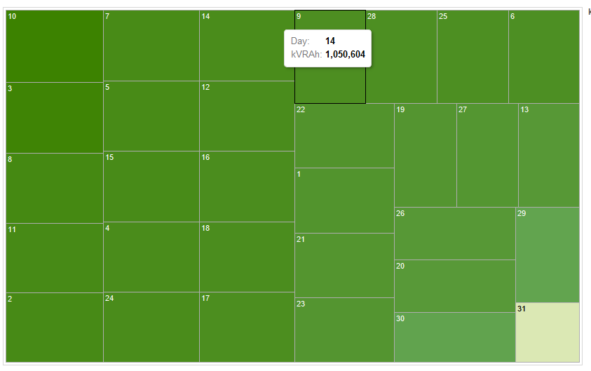

The Marco Energy Consumption with working day and no-working day

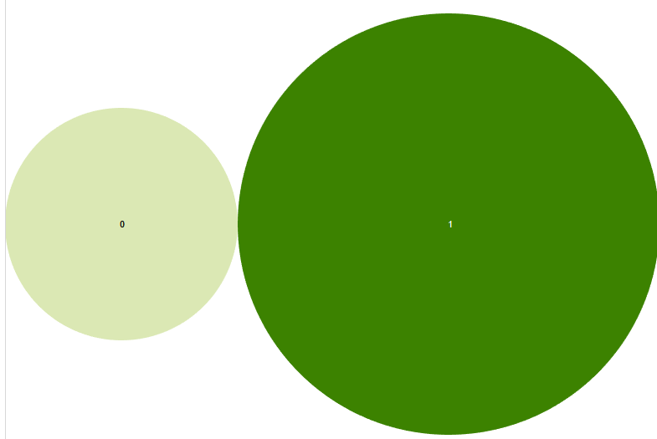

Energy Consumption – Total Value Through the Year

According to the graph we can easily distinguish the changes from month to month in one year, and changes from day by day in each month. The next step for our analysis is to get the whole trend of energy consumptions in the whole year on the unit of date.

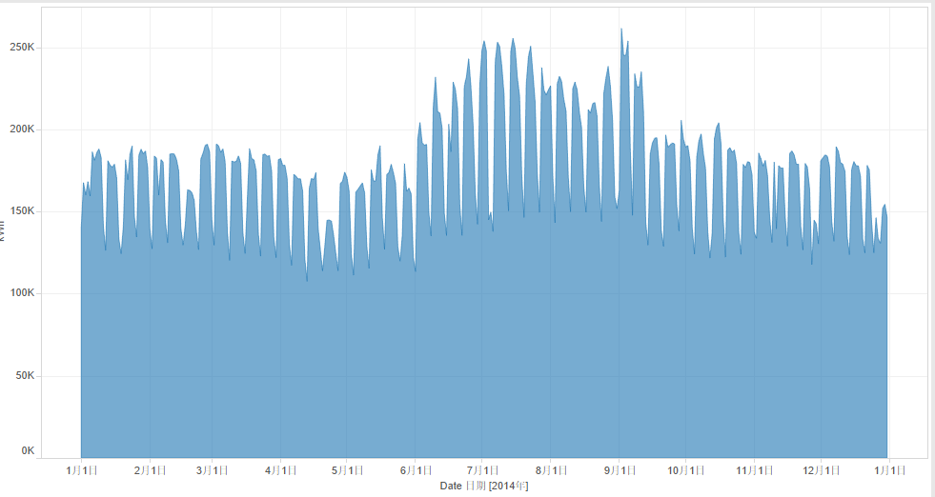

Marco Energy Consumption – Temperature/Humidity

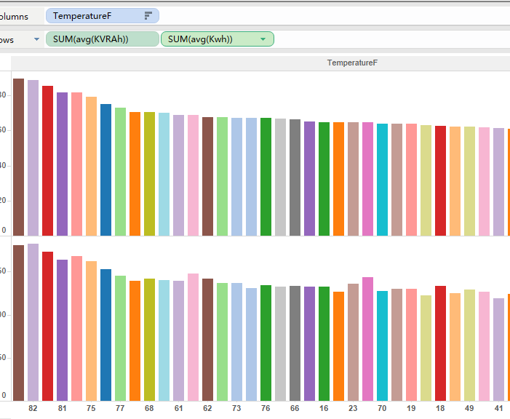

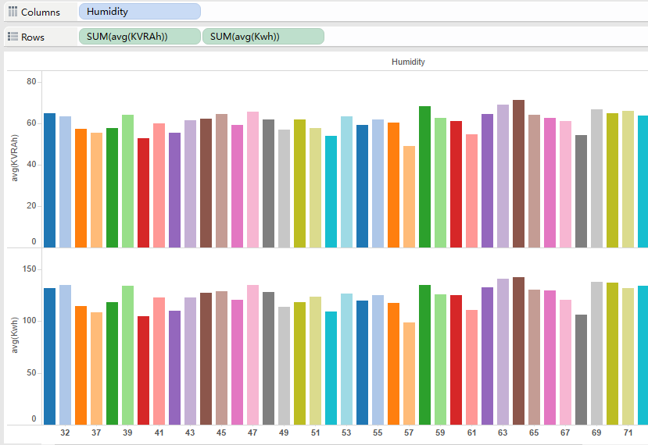

Micro-Analysis

After analysis the Marco trend of energy consumption, we now focus more on micro- analysis and their energy consumptions related to temperature, humidity and so on.

First diagram shows the energy consumption differs area by area.

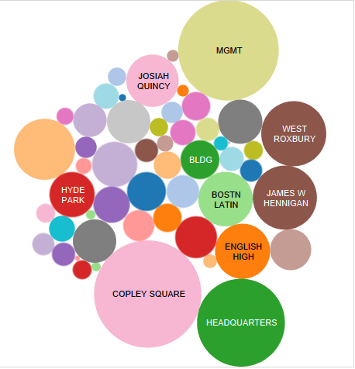

The box-graph also offer us a clear visual for building’s power-factors.

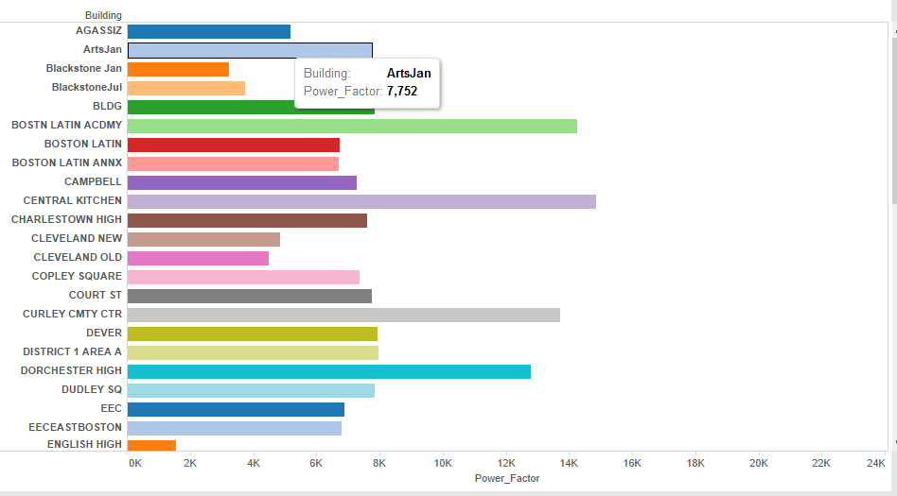

There is also a diagram display the use of electricity of each day, though difference exit in each building, while compare to themselves, the graph seems to be stable.

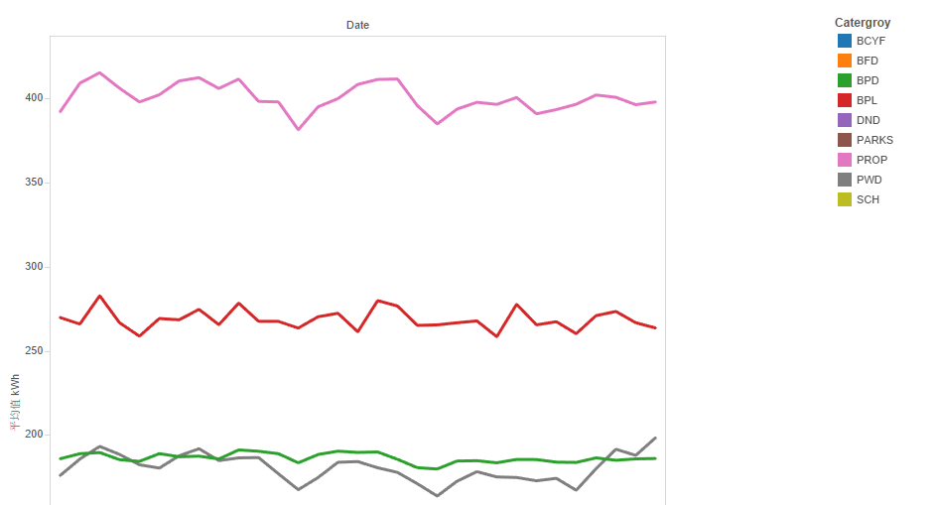

# **3.Model Building**

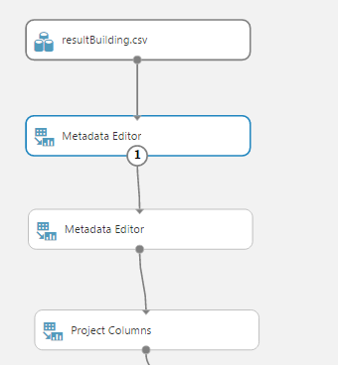

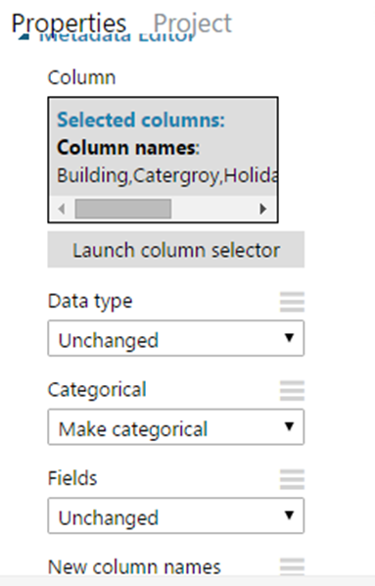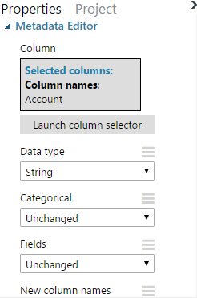3.1 Transform and pre-clean the data for analysis

3.2 Define category variables

For this exercise, the column that should be cast as categorical are: Building, Category, Holiday, working Day, Events. To cast these columns, drag in the metadata editor. Specify the columns to be cast, then change the “Categorical” parameter to “Make categorical”

For no-categorical values. We define the value of Account in type of String and stay in its original type.

3.3 Choosing the Variables for Training

We have already define the type of different variables. Now, we should continue by identifying columns that add little-to-no value for predictive modeling. These columns will be dropped.

The first, most obvious candidate to be dropped is Account. All information provided by Account can be replaced by the Buildings. Therefore, the keys could have been completely needlessness and may add false correlations or noise to our model.

The second candidate for removal is the Power_Factor column and KVRAH. Normally, there can be generated together with Kwh, their strong relationship may have bad effect for our prediction.

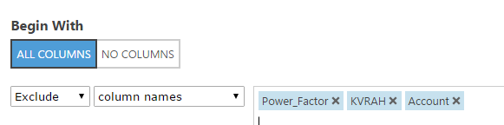

3.4 Split the Data and Training the model

# **4. Web Service**

4.1 The Web Architecture

We built the front end web page in Bootstrap framework. The web page used a form to collect the input information from users, then the form submit the input to the backend, which is implemented by Spring MVC. Spring MVC parsed the data into JSON format and then sent the data to the RESTful service. The Spring MVC also received the response from the Microsoft Azure, parsed the data and picked the output, then sent the output to the front page to users’ side.

4.2 Front End

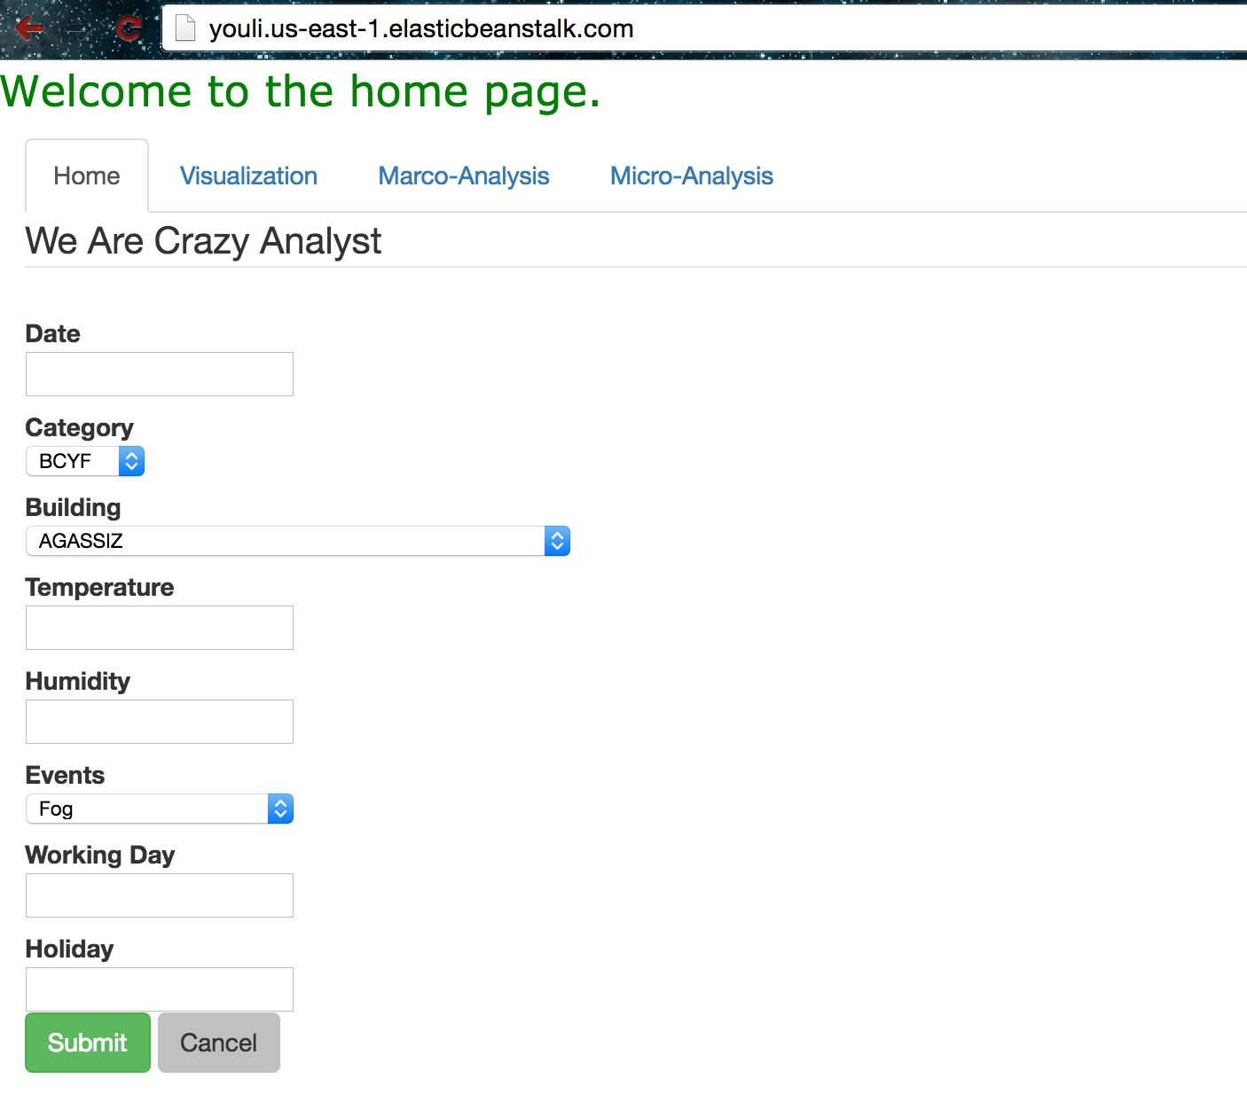

We use Bootstrap to create front end, the visualization tag is the link to the tableau page. And we use a simple form to collect the user’s input.

4.3 Spring MVC

We use Spring MVC to parse the user’s input data into JSON format. And then sent the request to the Azure model.

4.3.1 Set the header for building Connections

According to the API document, we have to add header to the request.

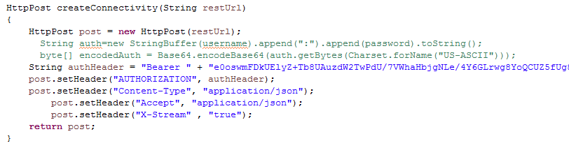

Firstly, we set the post’s header by setting parameters and connect the author Header to our API. The format of our data are setting in JSON.

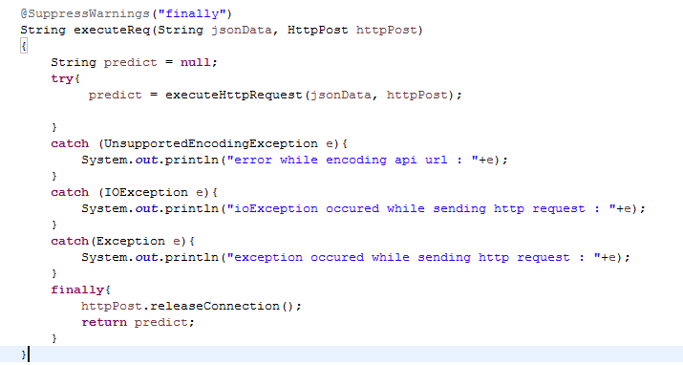

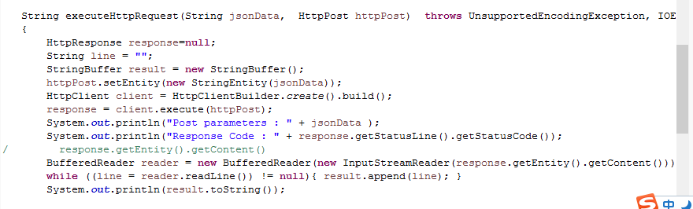

4.3.2 Executing process.

In the Home Controller, we firstly direct get the data from front page and transform it into JSON format.

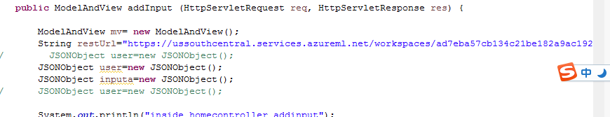

Since we have already define the Httppost method, what we need to do next is to send the data into Azure through our API key. Then print the value of its output.

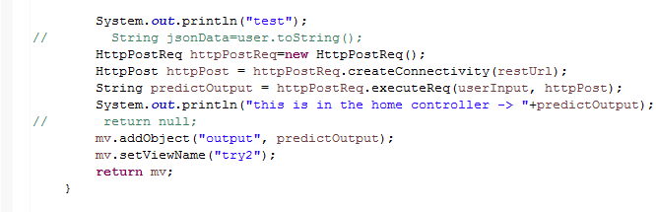

**Attachment**

R-1

#get catergroy and building

listTitle <- unlist(strsplit(filename, "\\."))

listTitle

Catergroy <- unlist(strsplit(listTitle[1],"-"))[2]

Catergroy

building <- listTitle[2]

building

#transponse column sucessful

rowdata <- read.csv(filename,header = FALSE)

titlerow <- rowdata[1,]

titlerow1 <- titlerow[,c(-1,-2,-3,-4)]

titlecolumn <- t(titlerow1)

dateTemp <- rowdata[1,2]

matrixTemp <- titlecolumn

firstTime <- TRUE

for (i in 2:nrow(rowdata)){

if(rowdata[i,2] != dateTemp){

if(!firstTime){

result <- rbind(result,matrixTemp)

}

if (i != 2 && firstTime){

result <- matrixTemp

firstTime <- FALSE

}

matrixTemp <- titlecolumn

matrixTemp <- cbind(matrixTemp, matrix(rep(rowdata[i,1],length(titlecolumn))))

matrixTemp <- cbind(matrixTemp, matrix(rep(rowdata[i,2],length(titlecolumn))))

}

matrixTemp <- cbind(matrixTemp,t(rowdata[i,c(-1,-2,-3,-4)]))

dateTemp = rowdata[i,2]

if(i == nrow(rowdata)){

result <- rbind(result,matrixTemp)

}

}

#Add Catergory and Building to dataset

numRows <- nrow(result)

result <- cbind(result, matrix(rep(Catergroy,numRows)))

result <- cbind(result, matrix(rep(building,numRows)))

#Derive day month year

listDate <- result[,3]

dayFun <- function(x) {

listTemp <- unlist(strsplit(x,"/"))

listTemp[2]

}

monthFun <- function(x){

listTemp <- unlist(strsplit(x,"/"))

listTemp[1]

}

yearFun <- function(x){

listTemp <- unlist(strsplit(x,"/"))

listTemp[3]

}

listDay <- lapply(listDate, dayFun)

listMonth <- lapply(listDate, monthFun)

listYear<- lapply(listDate, yearFun)

result <- cbind(result,listDay)

result <- cbind(result,listMonth,listYear)

R-2

uniqueRow<- data.frame(a = 1:nrow(result))

rownames(result)<- uniqueRow[,1]

result <- data.frame(result)

result <- sqldf("select Account, Date, Catergroy, Building,sum(Kwh) as Kwh,AVG(Power_Factor) as Power_Factor, sum(KVRAH) as KVRAH from reuslt group by Date")